**Kinjalk Parth**

**RA1911026010037**



**Objective:** The program to implement interprocess communication using shared memory and message queue concept.

**Program:1.** Shared memory implementation using readers writers

problem.

**Writer.c**

**#include <sys/ipc.h>**

**#include <sys/shm.h>**

**#include <stdio.h>**

**int main()**

**{**

**key_t key = ftok("shmfile",65);**

**int shmid = shmget(key,1024,0666|IPC_CREAT);**

**char *str = (char*) shmat(shmid,(void*)0,0);**

**printf("Write Data : ");**

**gets(str);**

**printf("Data written in memory: %s\n",str);**

**shmdt(str);**

**return 0;**

**}**

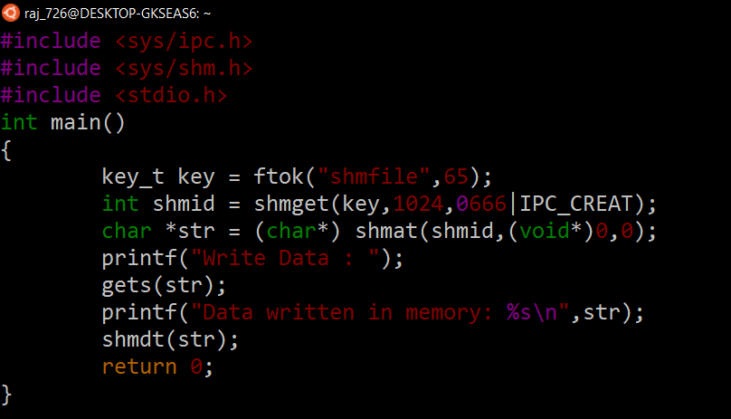

Reader.c

**#include <sys/ipc.h>**

**#include <sys/shm.h>**

**#include <stdio.h>**

**int main()**

**{**

**key_t key = ftok("shmfile",65);**

**int shmid = shmget(key,1024,0666|IPC_CREAT);**

**char *str = (char*) shmat(shmid,(void*)0,0);**

**printf("Data read from memory: %s\n",str);**

**shmdt(str);**

**shmctl(shmid,IPC_RMID,NULL);**

**return 0;**

**}**

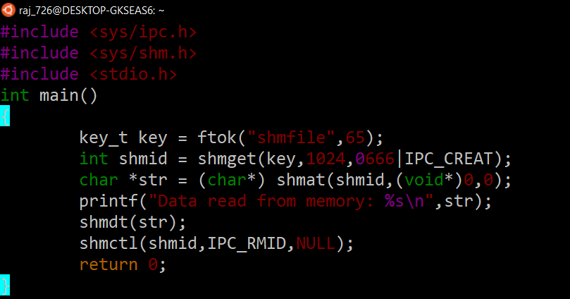

**OUTPUT:**

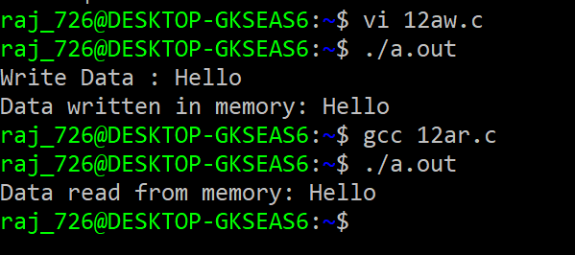

**Outcome:** Interprocess communication using shared memory concept learned and implemented.



**Objective:** The program to implement Inter process communication using message queue concept.

**Program:** To perform communication using message queues

**Writer.c**

**#include <stdio.h>**

**#include <sys/ipc.h>**

**#include <sys/msg.h>**

**#define MAX 10**

**struct mesg_buffer {**

**long mesg_type;**

**char mesg_text[100];**

**} message;**

**int main()**

**{**

**key_t key;**

**int msgid;**

**key = ftok("progfile", 65);**

**msgid = msgget(key, 0666 | IPC_CREAT);**

**message.mesg_type = 1;**

**printf("Write Data : ");**

**fgets(message.mesg_text,MAX,stdin);**

**msgsnd(msgid, &message, sizeof(message), 0);**

**printf("Data send is : %s \n", message.mesg_text);**

**return 0;**

**}**

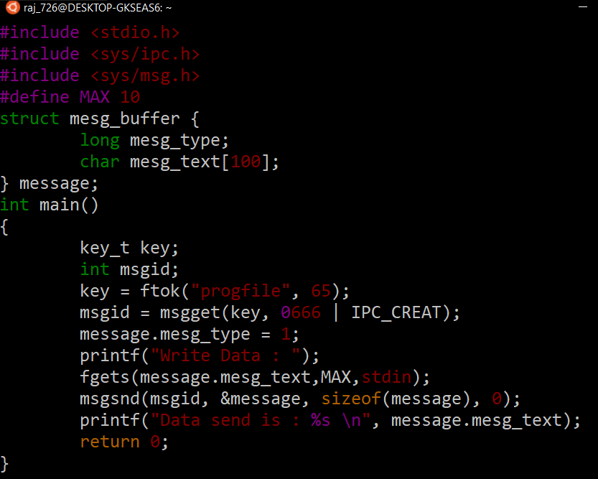

**Reader.c**

**#include <stdio.h>#include <sys/ipc.h>**

**#include <sys/msg.h>**

**struct mesg_buffer {**

**long mesg_type;**

**char mesg_text[100];**

**} message;**

**int main()**

**{**

**key_t key;**

**int msgid;**

**key = ftok("progfile", 65);**

**msgid = msgget(key, 0666 | IPC_CREAT);**

**msgrcv(msgid, &message, sizeof(message), 1, 0);**

**printf("Data Received is : %s \n", message.mesg_text);**

**msgctl(msgid, IPC_RMID, NULL);**

**return 0;**

**}**

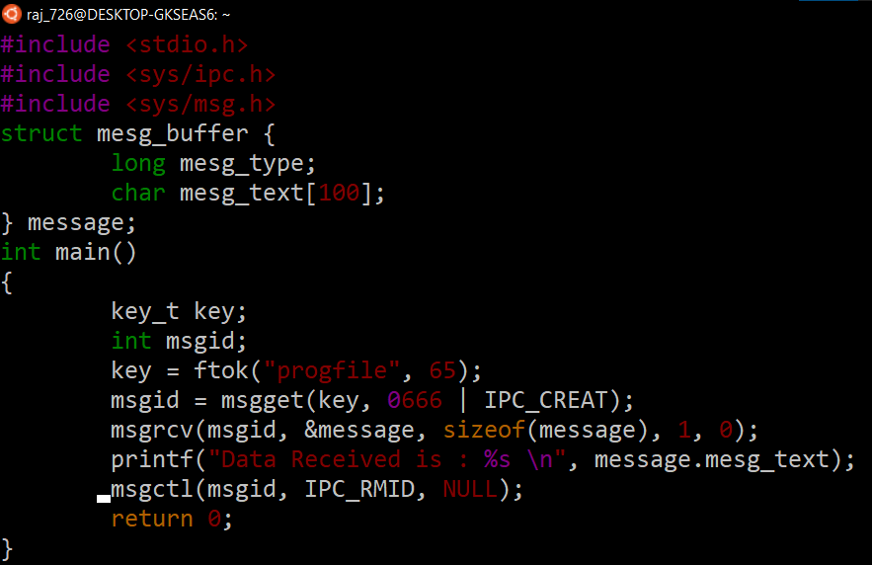

**OUTPUT:**

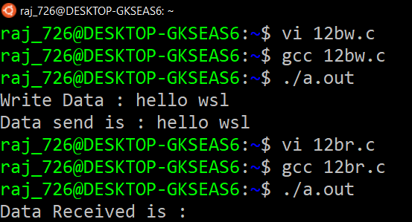

**Outcome:** Thus the concept of Interprocess Communication using message Queue has been implemented using readers writers problem